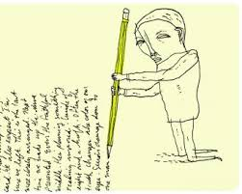
The topic of speaking or writing is assigned by the instructor, to have a participation or a practice which shows a variation in patterns of sentences that have different forms of phrases and clauses occupying different functions in those sentences.

